**Section one: Short answer 45 marks**

This section has **thirteen (13)** questions. Answer in the spaces provided.

Suggested working time: 40 minutes

1. The diagrams below show a metal solid at different temperatures; the dots represent individual atoms. Which diagram would represent the solid at a higher temperature? Describe the physics behind your decision.

|  |  |  |  |  |  |
| --- | --- | --- | --- | --- | --- |
|  |  |  |  |  |  |
|  |  |  |  |  |  |
|  |  |  |  |  |  |
|  |  |  |  |  |  |
|  |  |  |  |  |  |
|  |  |  |  |  |  |

(3 marks)

|  |  |  |  |  |  |
| --- | --- | --- | --- | --- | --- |
|  |  |  |  |  |  |
|  |  |  |  |  |  |
|  |  |  |  |  |  |
|  |  |  |  |  |  |
|  |  |  |  |  |  |
|  |  |  |  |  |  |

Diagram A Diagram B

1. Here is a collection of examples that contain heat energy that you may have encountered in daily life.

A) a bathtub with 100 litres of water at 20 °C

B) a sink filled with 10 litres of hot water at 90 °C

C) an oven filled with 1 kg of hot, dry air at 200 °C

D) a 100 g stainless steel heating element in a hair dryer at 150 °C

Use the letter of the real life situation above that best describes the following conditions: (no calculations required)

(5 marks)

a) Which has the highest temperature?

b) Which contains the most heat energy?

c) Which contains the least heat energy?

d) Which has the highest average kinetic energy per atom?

e) Which would increase temperature the most if 1000 J of energy were added?

1. 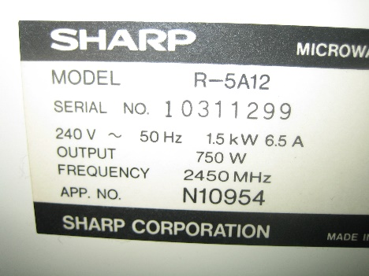The label on the right is a compliance plate found on an old microwave.
   1. Using the values given, calculate the resistance of the microwave’s internal circuitry.

(2 marks)

* 1. Compare the input power to the output power. What is the efficiency and where does the lost energy go?

(2 marks)

1. A torch bulb has 2.35 volts of potential difference applied across its contacts. What is the current flow if a charge of 16.8 coulombs is moving across the bulb every minute?

(2 marks)

1. Draw a diagram showing how you would connect a group of 4.00 Ω resistors (use as many as you need) to achieve an overall resistance of 5.00 Ω.

(2 marks)

1. 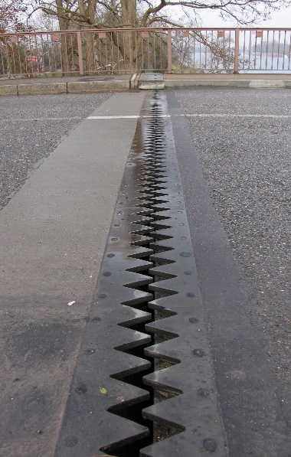A picture of an expansion joint in a road bridge is shown. Is this picture taken during a cold or warm day? Justify your answer using physics principles.

(3 marks)

1. The following circuit diagram shows the connections of three similar resistors (labelled 1, 2 and 3).

C

E

F

G

A

B

D



2



1



3

(4 marks)

* 1. The direction of conventional current flow is from

Circle the correct answer: G to A B to A D to A

* 1. To determine the potential difference across resistor 2, you would use points

Circle the correct answer: A and C A and F B and C

* 1. There is no potential difference between points

Circle the correct answer: A, D and G A, B and C E, F and G

* 1. Comparing the amount of current going through points A, D and G, the order from the greatest amount of current to the least is

Circle the correct answer: A, D then G G, A then D G, D then A

1. A kettle is brought to the boil from 25.0 °C and left boiling for 3.50 minutes. Half of the 1.250 litres of water boils away in that time, leaving 0.625 litres boiling. How much energy has been transferred?

(3 marks)

1. A 75.0 W / 240 V light globe is left on for 10.0 hours. How much energy does it use?

(3 marks)

1. A 21.7 g block of aluminium, which is initially at a temperature of 17.5 °C, is added to a 55.5 g copper calorimeter containing 153 mL of water at 60.0 °C. What is the final temperature of the aluminium block after the system has achieved thermal equilibrium? Assume no energy is lost.

(3 marks)

1. Jennifer was investigating the activity of 15.00 g of an unknown radioisotope. The original activity of the sample was 8.00 kBq and Jennifer had already determined that its half-life was four days.
2. What would its activity be 12 days later?

(2 marks)

1. Jennifer also had another 100 g sample of the same radioisotope. Would this second sample have a greater, equal or smaller half-life than the original 15.00 g sample of the radioisotope?

Circle the correct answer: GREATER EQUAL SMALLER

(1 mark)

1. 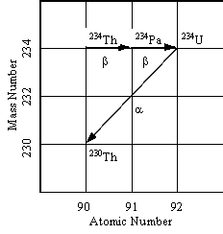The graph to the right shows part of the natural Thorium-234 radioactive decay series, continuing as far as Thorium-230.

* 1. Write the nuclear transformation equations for each decay reaction shown on the graph.

(3 marks)

* 1. For the above decays, Thorium-234 has a half-life of 24.1 days, and Protactinium-234 has a half-life of 6.75 hours.

(3 marks)

* + 1. How does the weight of the same number of atoms of Thorium-234 compare to the same number of atoms Protactinium-234?

Circle the correct answer: GREATER EQUAL SMALLER

* + 1. Given the same number of atoms of Thorium-234 and Protactinium‑234, which sample would have the greatest number of decays per second?

Circle the correct answer: Thorium-234 EQUAL Protactinium-234

* + 1. What happens to the weight of a sample of Thorium-234 when half of it has it decayed to Protactinium-234?

Circle the correct answer: DOUBLES EQUAL HALVES

1. After an animal dies it no longer takes in Carbon-14, so that the ratio of C-14 (radioactive) to C-12 (not radioactive) gradually decreases. C-14 undergoes β‑decay and has a half-life of about 5730 years. The decay rate of C-14 in a living animal is around 15 decays/minute per gram of carbon. Toby and Oren, who are archaeologists, finds what they thinks is a dinosaur bone. The bone has a mass of 425 g of carbon. The β-decay rate from the whole bone is 50 decays/minute. What is the approximate age of the bone and based on this information, do you think Toby and Oren have a dinosaur bone (dinosaurs died out about 65 million years ago)?

(4 marks)

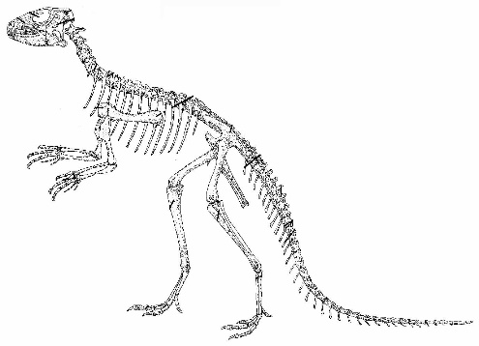**Section two: Problem-solving 60 marks**

This section has **six (6)** questions. Answer in the spaces provided.

Suggested working time: 65 minutes

1. The graph below shows the change in temperature while heating a 20.0 g sample of an unknown solid. The total energy absorbed by the sample for each stage, A‑E, is given below:

[9 marks total]



**E**

**D**

**C**

**B**

**A**

a)Which of the section(s) has the unknown material as a:

(3 marks)

i) Solid ________

ii) Gas ________

iii) Melting ________

b)Calculate the latent heat of vaporisation for this unknown material.

(3 marks)

c) Calculate the specific heat capacity of this material in the liquid phase.

(3 marks)

1. Alex is an industrial physicist who accidentally swallows a radioisotope with an activity of 10.0 kBq. The material swallowed has a very long half-life. You can assume therefore that the activity will not change appreciably during Alex’s lifetime. Each decay of the isotope releases 1.60 x 10-13 J of energy into the body and that the radioisotope is not eliminated from the body.

[8 marks total]

* 1. Calculate the amount of energy absorbed in one non-leap year.

(3 marks)

1. If Alex has a mass of 70.0 kg, calculate the absorbed dose in one year.

(2 marks)

1. Assuming that the ingested radioisotope is an alpha emitter, what is the dose equivalent absorbed per year?

(2 marks)

1. Should Alex be concerned about this yearly radiation exposure? Explain.

(1 mark)

___________________________________________________________________________

___________________________________________________________________________

______________________________________________________________________________________________________________________________________________________

1. The following circuit is made with the resistors as shown.

[9 Marks Total]

A

7Ω

2Ω

5Ω

11Ω

B

4Ω

9Ω

1. What is the effective resistance from Point A to Point B?

(2 marks)

1. If a potential difference of 24 volts is applied across this circuit from A to B, what current would flow?

(2 marks)

1. What would the current flow be through the 9 Ω resistor with the 24 volts applied?

(3 marks)

1. Using the resistors above, explain how you would rearrange the resistors above to create new circuits with the maximum and minimum resistance possible. (No calculation required.)

(2 marks)

1. 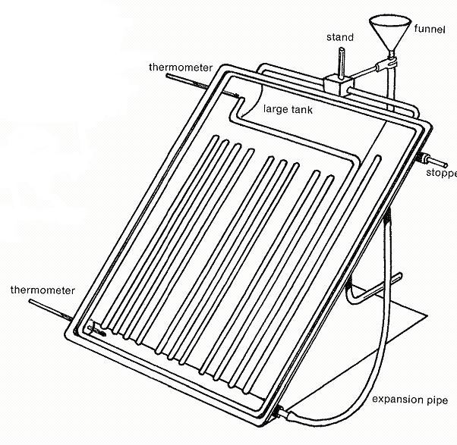A student has set up an experiment designed on building a passive solar hot water heater. She designs the apparatus as shown, places it in a sunny area and records the temperatures. After an hour, the temperatures are recorded again. The thermometers are digital, with readings in whole numbers only (no decimals). The table has begun to be filled in.

[13 Marks total]

1. Complete the table.

(2 marks)

|  |  |  |  |
| --- | --- | --- | --- |
|  | Initial  Temperature | Final  Temperature | Temperature Difference |
| Top | 20 °C | 75 °C |  |
| Bottom | 20 °C | 31 °C |  |

1. Explain using the kinetic theory why the water is warmer at the top of the apparatus than at the bottom at the end of the experiment.

(3 marks)

1. The student has chosen to paint the apparatus black. Explain why she has made this choice.

(2 marks)

1. Over the next few days, the student completed the experiment four more times. The results are shown on the table. Graph the results below.

|  |  |  |  |  |  |
| --- | --- | --- | --- | --- | --- |
| Experiment | 1 | 2 | 3 | 4 | 5 |
| Time (minutes) | 60 | 20 | 40 | 10 | 80 |
| Temperature Change (oC) | 55 | 20 | 35 | 12 | 65 |

(3 marks)

|  |  |  |  |  |  |  |  |  |  |  |  |  |  |  |  |  |  |  |  |  |  |  |
| --- | --- | --- | --- | --- | --- | --- | --- | --- | --- | --- | --- | --- | --- | --- | --- | --- | --- | --- | --- | --- | --- | --- |
|  |  |  |  |  |  |  |  |  |  |  |  |  |  |  |  |  |  |  |  |  |  |  |
|  |  |  |  |  |  |  |  |  |  |  |  |  |  |  |  |  |  |  |  |  |  |  |
|  |  |  |  |  |  |  |  |  |  |  |  |  |  |  |  |  |  |  |  |  |  |  |
|  |  |  |  |  |  |  |  |  |  |  |  |  |  |  |  |  |  |  |  |  |  |  |
|  |  |  |  |  |  |  |  |  |  |  |  |  |  |  |  |  |  |  |  |  |  |  |
|  |  |  |  |  |  |  |  |  |  |  |  |  |  |  |  |  |  |  |  |  |  |  |
|  |  |  |  |  |  |  |  |  |  |  |  |  |  |  |  |  |  |  |  |  |  |  |
|  |  |  |  |  |  |  |  |  |  |  |  |  |  |  |  |  |  |  |  |  |  |  |
|  |  |  |  |  |  |  |  |  |  |  |  |  |  |  |  |  |  |  |  |  |  |  |
|  |  |  |  |  |  |  |  |  |  |  |  |  |  |  |  |  |  |  |  |  |  |  |
|  |  |  |  |  |  |  |  |  |  |  |  |  |  |  |  |  |  |  |  |  |  |  |
|  |  |  |  |  |  |  |  |  |  |  |  |  |  |  |  |  |  |  |  |  |  |  |
|  |  |  |  |  |  |  |  |  |  |  |  |  |  |  |  |  |  |  |  |  |  |  |
|  |  |  |  |  |  |  |  |  |  |  |  |  |  |  |  |  |  |  |  |  |  |  |
|  |  |  |  |  |  |  |  |  |  |  |  |  |  |  |  |  |  |  |  |  |  |  |
|  |  |  |  |  |  |  |  |  |  |  |  |  |  |  |  |  |  |  |  |  |  |  |
|  |  |  |  |  |  |  |  |  |  |  |  |  |  |  |  |  |  |  |  |  |  |  |
|  |  |  |  |  |  |  |  |  |  |  |  |  |  |  |  |  |  |  |  |  |  |  |
|  |  |  |  |  |  |  |  |  |  |  |  |  |  |  |  |  |  |  |  |  |  |  |
|  |  |  |  |  |  |  |  |  |  |  |  |  |  |  |  |  |  |  |  |  |  |  |
|  |  |  |  |  |  |  |  |  |  |  |  |  |  |  |  |  |  |  |  |  |  |  |

1. What conclusion can be drawn about the relationship in the graph above?

(1 mark)

1. If the initial temperature of the water was 17 °C, what would you expect the final temperature of the water to be after 50 minutes?

(2 marks)

1. A Year 12 Physics student is trying to find a quiet place to study, so moves into a shed in the back yard. He doesn’t want to do without modern conveniences so gets a long extension cord from his parents’ place to the shed. He uses a power board to plug in all the appliances. The shed now has 240 V supplied to:
   * 60 W light bulb in a lamp
   * 1000 W bar heater
   * 750 W microwave [10 Marks Total]

a) The power board has a circuit breaker rated at 10 A. Will it trip if all of the appliances are turned on?

(3 marks)

b) Calculate the resistance of the 750 W microwave.

(3 marks)

c) When all the devices are operating, how does the total resistance of the circuit compare to that of just the microwave? (No calculations required)

(1 mark)

Circle the correct answer: GREATER EQUAL SMALLER

d) The element of the heater is a non-Ohmic conductor. Just after it is turned on it begins to increase in temperature and the current drawn changes. Use the kinetic theory to explain what happens to the current (and therefore resistance) as the element warms up to operating temperature.

(3 marks)

1. Uranium-233 can undergo fission when struck by a thermal neutron producing many different types of daughter nuclei. One possible split is shown in the following formula:

[11 marks total]

 +  →  +  + _____ + energy

1. How many neutrons are released during this fission process? (fill in the blank above)

(1 mark)

|  |  |
| --- | --- |
| **Isotope** | **Mass (u)** |
| Neutron | 1.008665 |
| Uranium – 233 | 233.039635 |
| Tellurium - 140 | 139.938854 |
| Zirconium - 90 | 89.904708 |

1. Given the atomic masses in the table, calculate the mass defect in kilograms for this fission process.

(3 marks)

1. Calculate the energy released during the fission of one uranium-233 () atom. (If you were unable to determine the mass defect in (b), use the value 3.00 × 10-28 kg.)

(2 marks)

1. The first British atomic test in Australia on the 3rd of October 1952 on the Monte Bello Islands had a yield of 25 kt, or about 1 × 1015 J. Assuming the above energy release is the average per Uranium-233 () atom and was the main constituent, what mass of atoms underwent fission during this test?

(3 marks)

1. This mass of uranium-233 is higher than the ‘critical mass’ value. What does ‘critical mass’ mean, and how might the engineers have been able to transport this mass without the bomb going ‘supercritical’ and exploding at the assembly site?

(2 marks)

**Section three: Comprehension 10 marks**

This section has **one (1)** question. Answer in the spaces provided.

1. Recollections of my Grandmother

I remember many pleasant Sunday mornings sitting with my Grandmother as she told me stories of her life which was very different to mine. She loved to talk about when she was a young girl and learnt that her family was to move to the ‘big city’. Hers was a large family and some of the younger children, herself included, had never been to Melbourne. She remembered being very excited about it.

There was such excitement when she arrived at her new home in Melbourne as it was equipped with electricity for lighting and gas for cooking, heating, so very modern and so very different from her country home. Some of the surrounding homes were still lit by gas mantels, gas stoves replaced the wood-fuelled ones (which had made kitchens so hot in summer) and small gas-heated water cisterns appeared on kitchen walls to service the sink. Washing was speeded up in gas-heated coppers and gas fires replaced the cheerful (but yet wasteful) wood fires in open fireplaces. Electricity was gradually appearing on the scene, but until probably well into the 1920s the normal suburban household was equipped with only one power point – usually for the electric iron. The socket had two holes only (no earth). She remembered when she first moved into their new house, her mother proudly showing her where the wonderful new electric iron was to be connected, by touching the socket with two of her fingers. Unfortunately she gave herself a nasty electric shock which gave everyone a good laugh later. With the current safety devices installed in our homes today, that is less likely to happen now.

She remembered that then there were no vacuum cleaners, electric blenders and other appliances we take for granted today, and she was the dish washer! The first electrical kitchen aids were the electric iron and toaster, and a small one-bar radiator for winter. With only one electrical outlet, double adapters boomed. Fitted into the central hanging light socket, one could connect a radiator or toaster, as long as the old fuses didn’t blow! With the advent of other electrical implements, electricians must have reaped a small fortune rewiring houses and installing power points in every room. It was certainly different then.

1. Up until the 1920s, most homes only had one power point. What was this usually used for?

(2 marks)

__________________________________________________________________________

__________________________________________________________________________

1. Early electrical homes had no earth wire. What is the purpose of an earth wire?

(1 marks)

_____________________________________________________________________________________________________________________________________________________________________________________________________________________________________________________________________________________________________________________________________________________________________________

1. Many appliances today such as hairdryers don’t have an earth connection. Explain how are these appliances are made safe?

(2 marks)

_____________________________________________________________________________________________________________________________________________________________________________________________________________________________________________________________________________________________________________________________________________________________________________

1. Name one electrical safety device in the home and explain how it works.

(2 marks)

_____________________________________________________________________________________________________________________________________________________________________________________________________________________________________________________________________________________________________________________________________________________________________________

1. Modern homes have many power points and light switches. Often, one light can be controlled by two switches.

(1 mark)

In the diagram below, is the light from the two-way switch on or off? _________________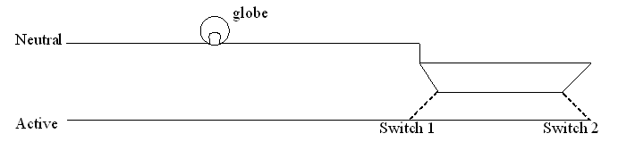

1. Light globes are non-ohmic resistors. Explain what this means. Include diagrams to aid your explanation.

(3 marks)

_____________________________________________________________________________________________________________________________________________________________________________________________________________________________________________________________________________________________________________________________________________________________________________

**End of Examination**